# Travel Approval PowerApps Sample

## Overview

The Travel Request PowerApps allows company employees to easily submit travel requests from desktop or mobile devices. Travel Requests are automatically routed to the appropriate Manager and Travel Department for approval. This reduces processing time. Managers can also access status reports for all travel requests to verify current status and manage the travel budget.

## Device Support

Travel Approval is available in both the Tablet and Phone form factors.

### Tablet

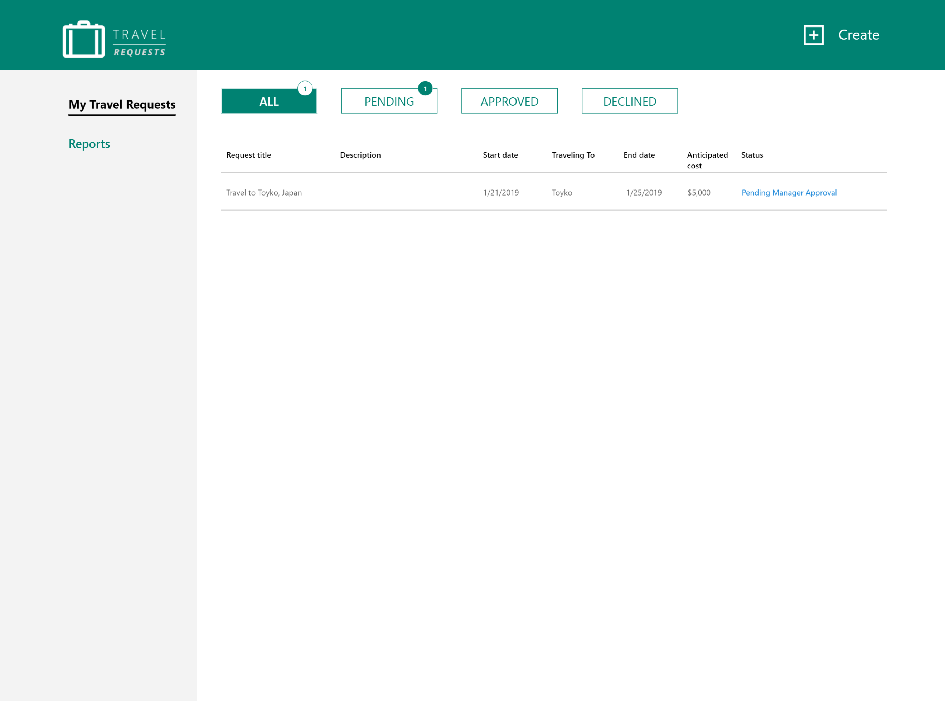

### Phone

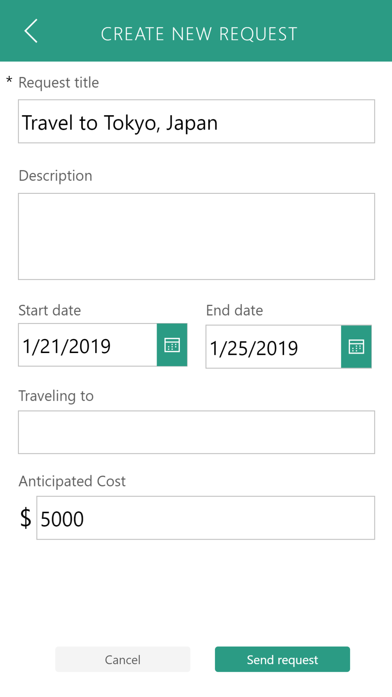

## Show me!

Watch **this video** to see an end-to-end demonstration of the functionality.

## Getting Started

See the installation instructions and **video** that describe and demonstrate how to install and set it up.

## Technical Details

### Connectors

Travel Approval uses the following Connectors to access Office 365 Services.

* [Office 365 SharePoint](https://docs.microsoft.com/en-us/connectors/sharepointonline/)

We hope you enjoy Travel Approval and look forward to hearing how you extend it for your organization!